**Practical No. 9**

**Write a simple PHP program on Introspection and Serialization**

**Code (Pgno. 75):**

<?php

if(class_exists("Demo"))

{

    $demo=new Demo();

    echo "This is Demo class";

}

else{

    echo "Class does not exists";

}

?>

**Output:**

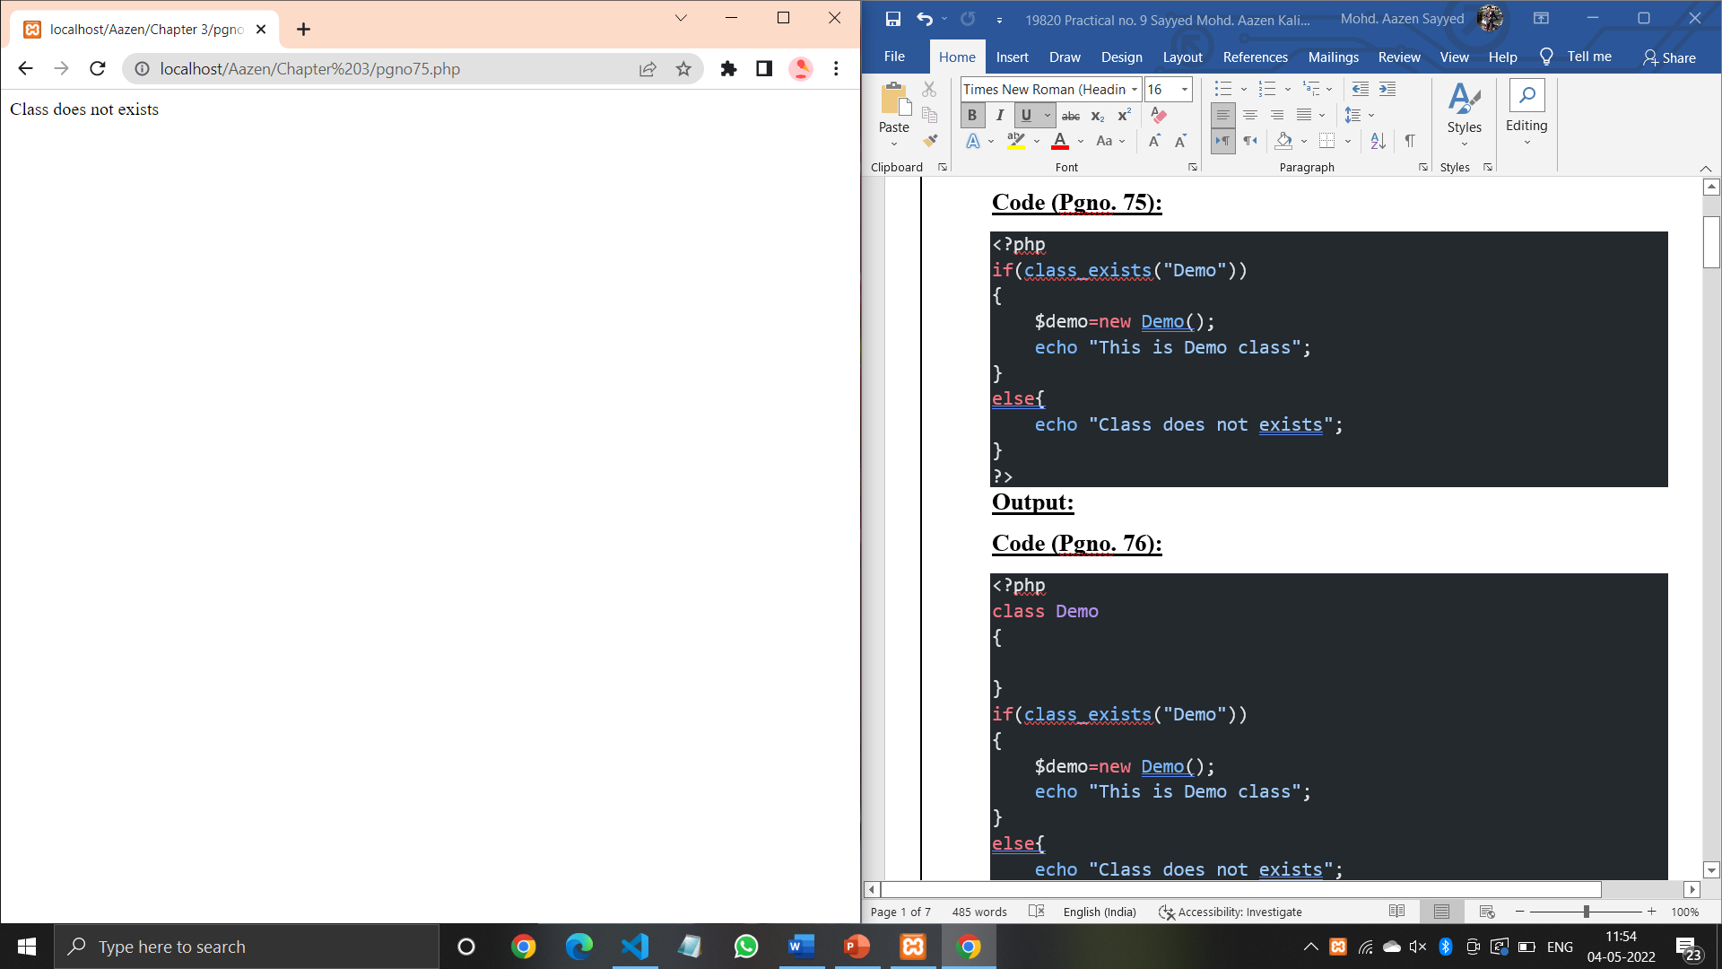

**Code (Pgno. 76):**

<?php

class Demo

{

}

if(class_exists("Demo"))

{

    $demo=new Demo();

    echo "This is Demo class";

}

else{

    echo "Class does not exists";

}

?>

**Output:**

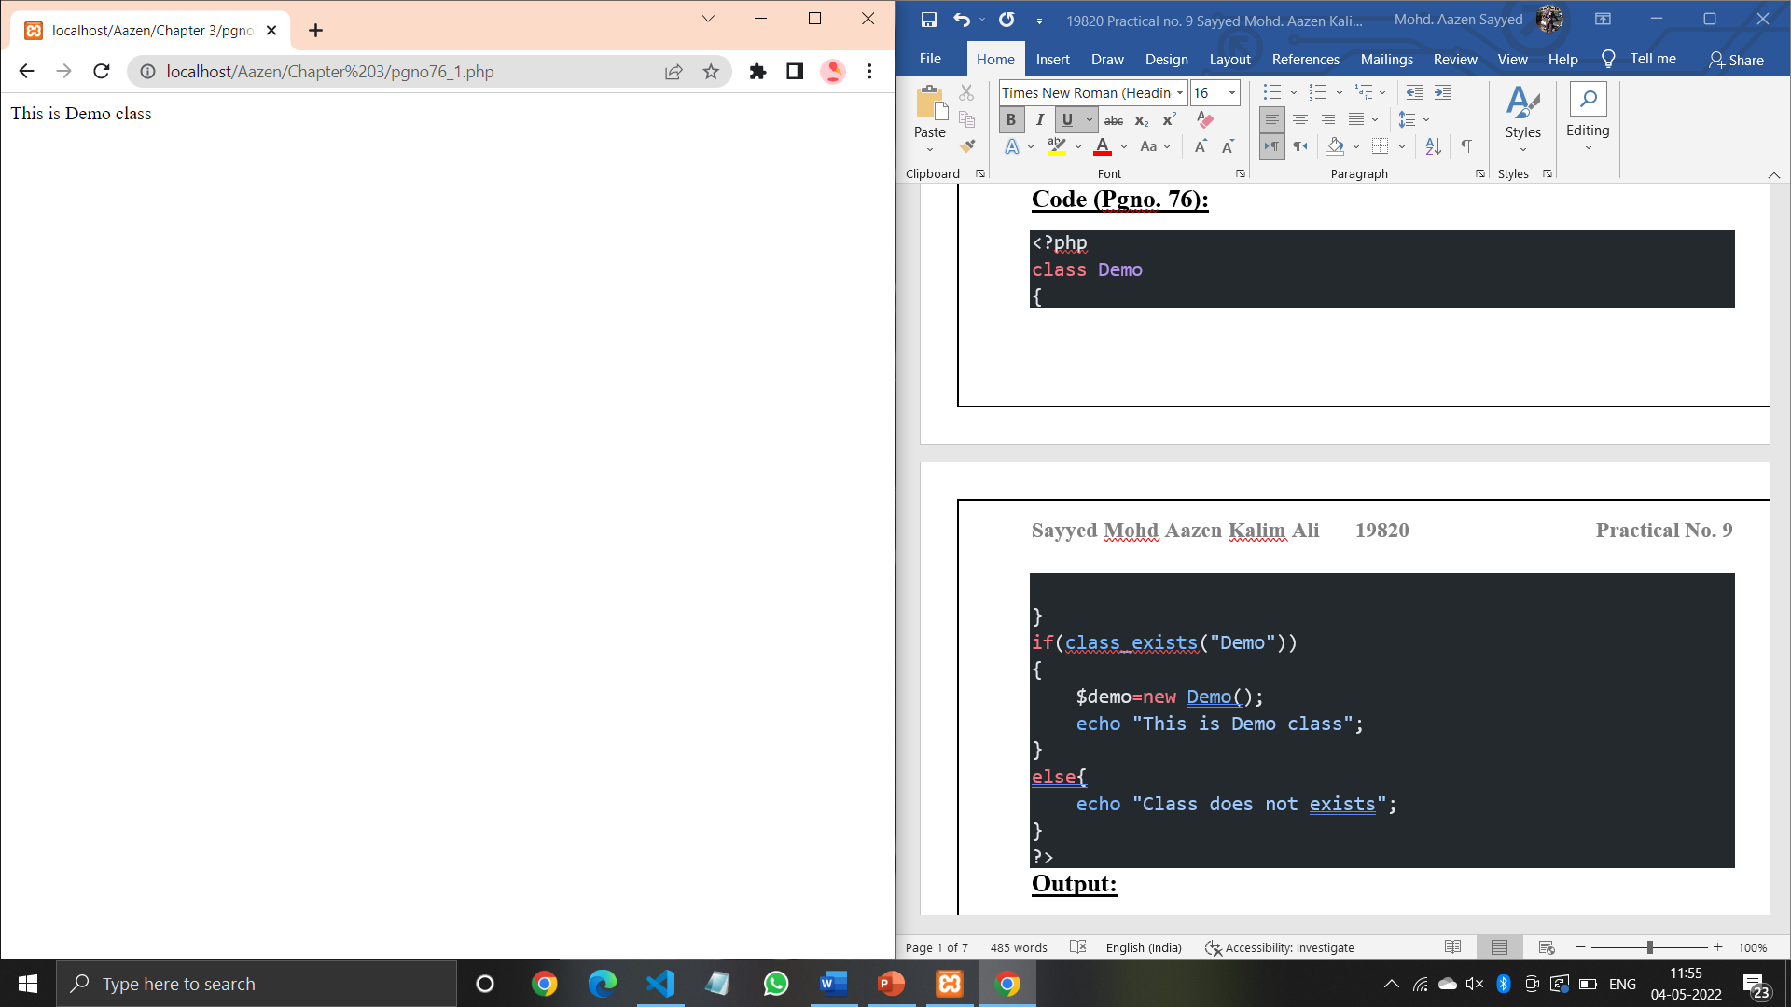

**Code (Pgno. 76):**

<?php

class Derived

{

    public function details()

    {

        echo "I am a developer(super) class for the child(sub) class. <br>";

    }

}

class sub extends Derived

{

    public function details()

    {

        echo "I'm ".get_class($this),"class.<br>";

        echo "I'm ".get_parent_class($this),"class.<br>";

    }

}

if(class_exists("Derived"))

{

    $der=new Derived();

    echo "The class name is :".get_class($der)."<br>";

    $der->details;

}

if (class_exists("sub"))

{

 $s = new sub();

 $s->details();

 if (is_subclass_of($s, "Derived"))

 {

 echo "Yes, " .get_class($s) . " is a subclass of Derived.<BR>";

 }

 else

 {

 echo "No, " .get_class($s) . " is not a subclass of Derived.<BR>";

 }

}

?>

**Output:**

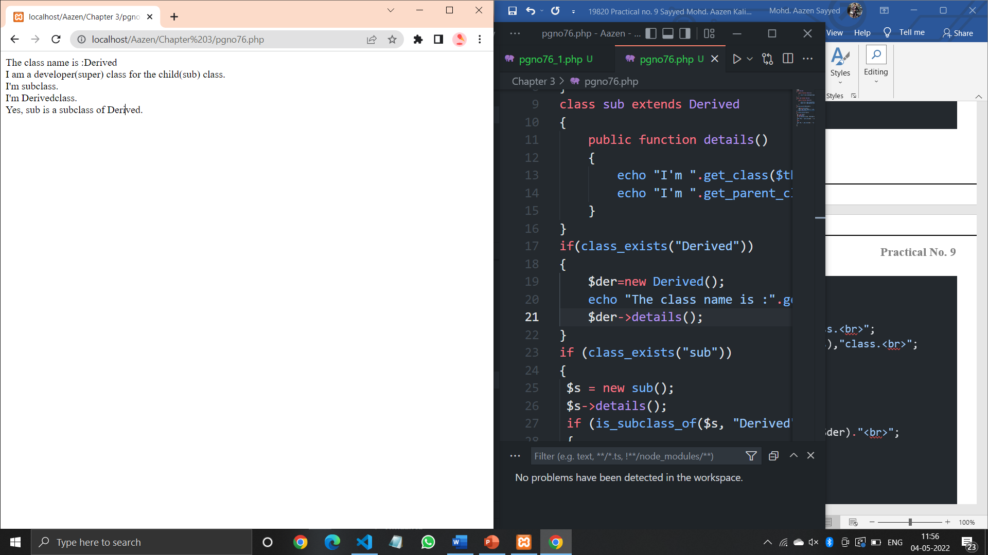

**Code (Pgno. 77):**

<?php

class Demo

{

    // just declare the class as "Demo'

    }

    if (class_exists('Demo'))

     {

     $demo = new Demo();

     echo "This is Demo class";

     }

    else

     {

     echo "Class does not exist";

     }

?>

**Output:**

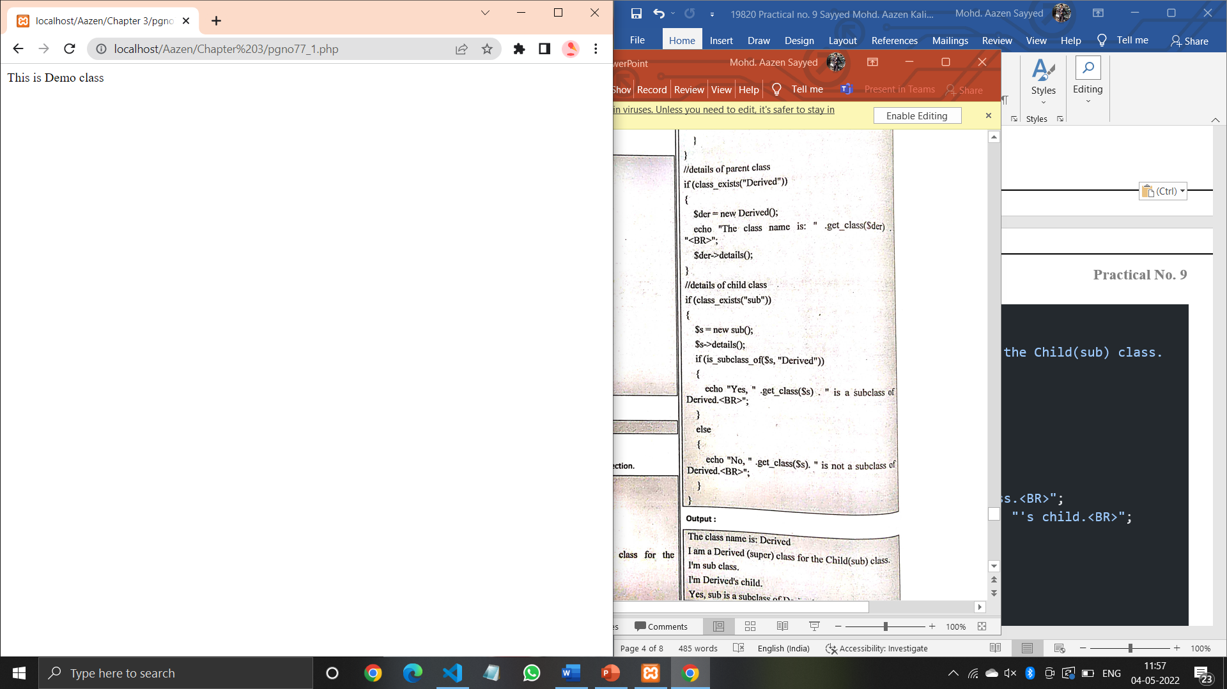

**Code (Pgno. 77):**

<?php

class Derived

{

 public function details()

 {

 echo "I am a Derived(super) class for the Child(sub) class. <BR>";

 }

}

class sub extends Derived

{

 public function details()

{

 echo "I'm " .get_class($this) , " class.<BR>";

 echo "I'm " .get_parent_class($this) , "'s child.<BR>";

 }

}

//details of parent class

if (class_exists("Derived"))

{

 $der = new Derived();

 echo "The class name is: " .get_class($der) . "<BR>";

 $der->details();

}

//details of child class

if (class_exists("sub")) {

 $s = new sub();

 $s->details();

 if (is_subclass_of($s, "Derived")) {

 echo "Yes, " .get_class($s) . " is a subclass of Derived.<BR>";

 }

 else{

 echo "No, " .get_class($s) . " is not a subclass of Derived.<BR>";

 }

}

**Output:**

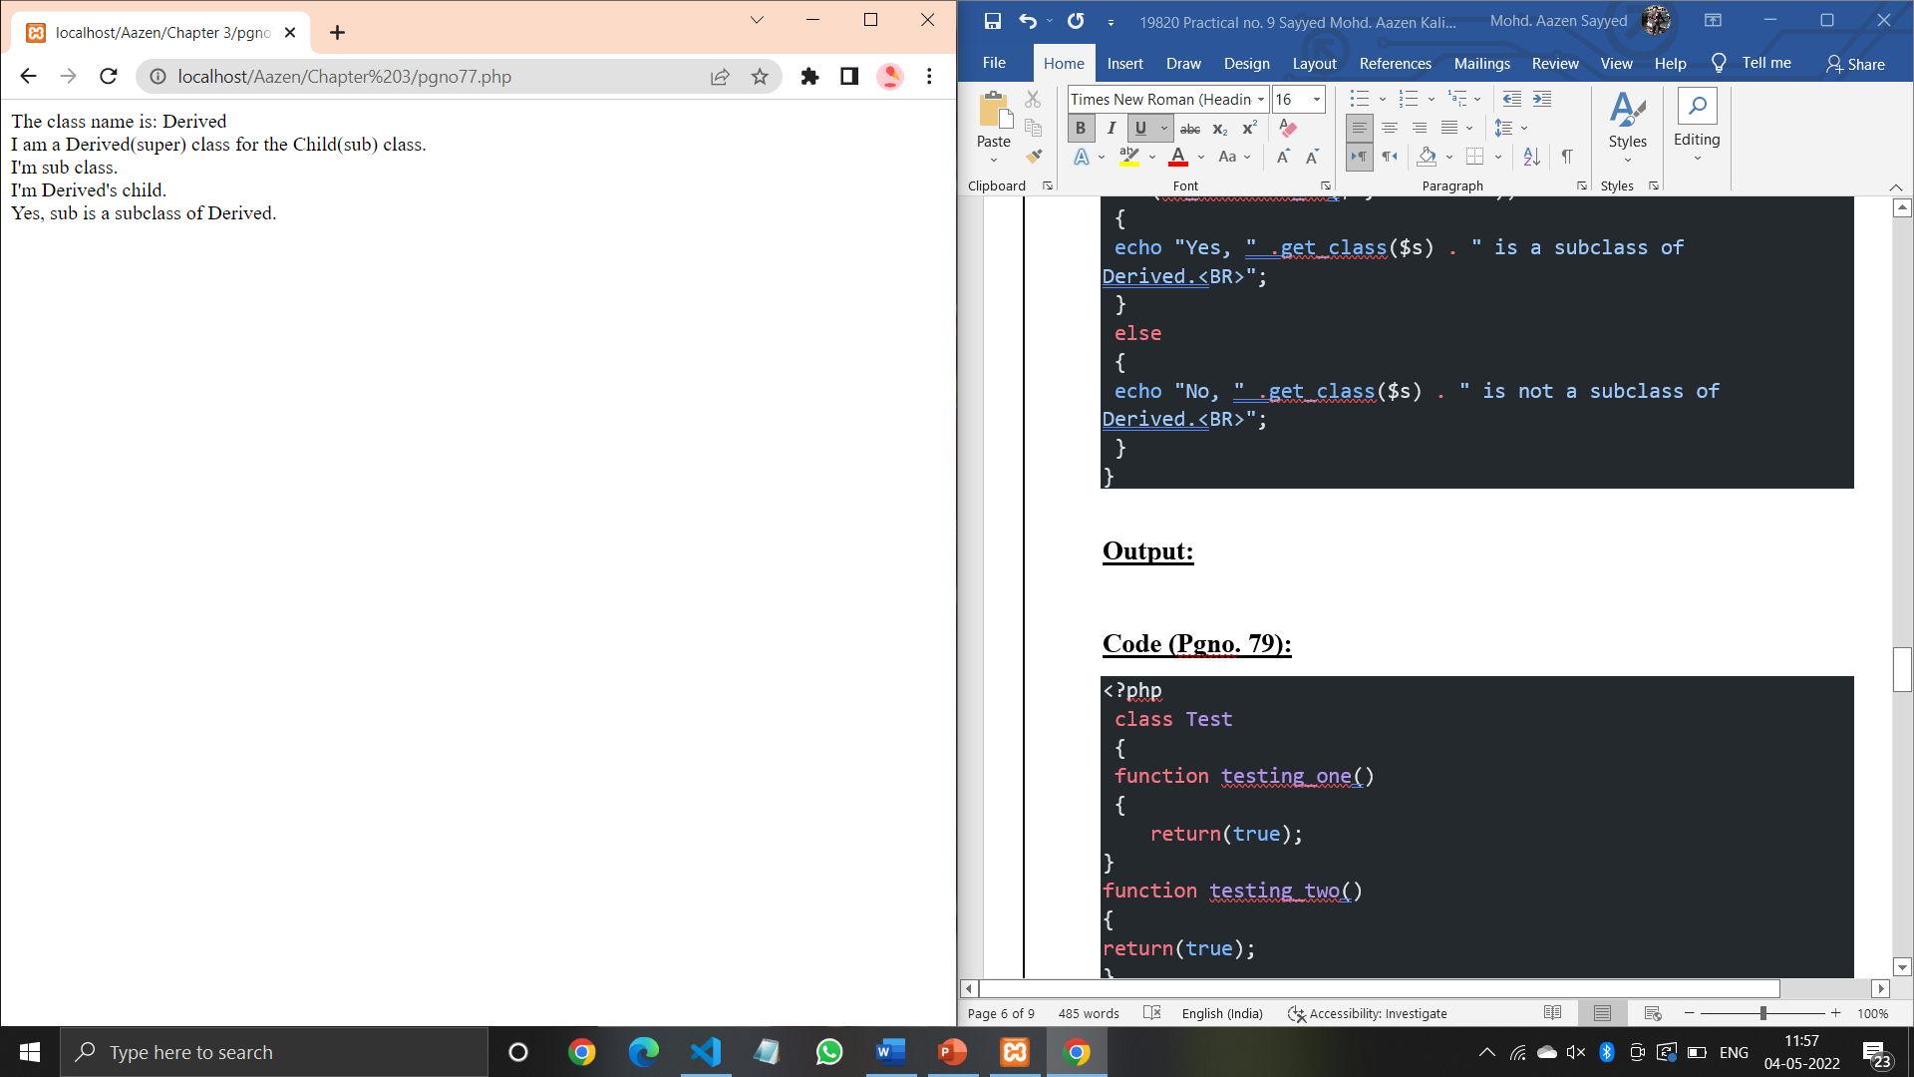

**Code (Pgno. 79):**

<?php

 class Test

 {

 function testing_one()

 {

    return(true);

}

function testing_two()

{

return(true);

}

function testing_three()

{

return(true);

}

}

//Class "Test" exist or not

if (class_exists('Test'))

{

$t = new Test();

echo "The class is exist. <br>";

}

else

{

echo "Class does not exist. <br>";

}

//Access name of the class

$p= new Test();

echo "Its class name is " ,get_class($p) , "<br>";

//Aceess name of the methods/functions

$method = get_class_methods(new Test());

echo "<b>List of Methods:</b><br>";

foreach ($method as $method_name)

{

echo "$method_name<br>";

}

?>

**Output:**

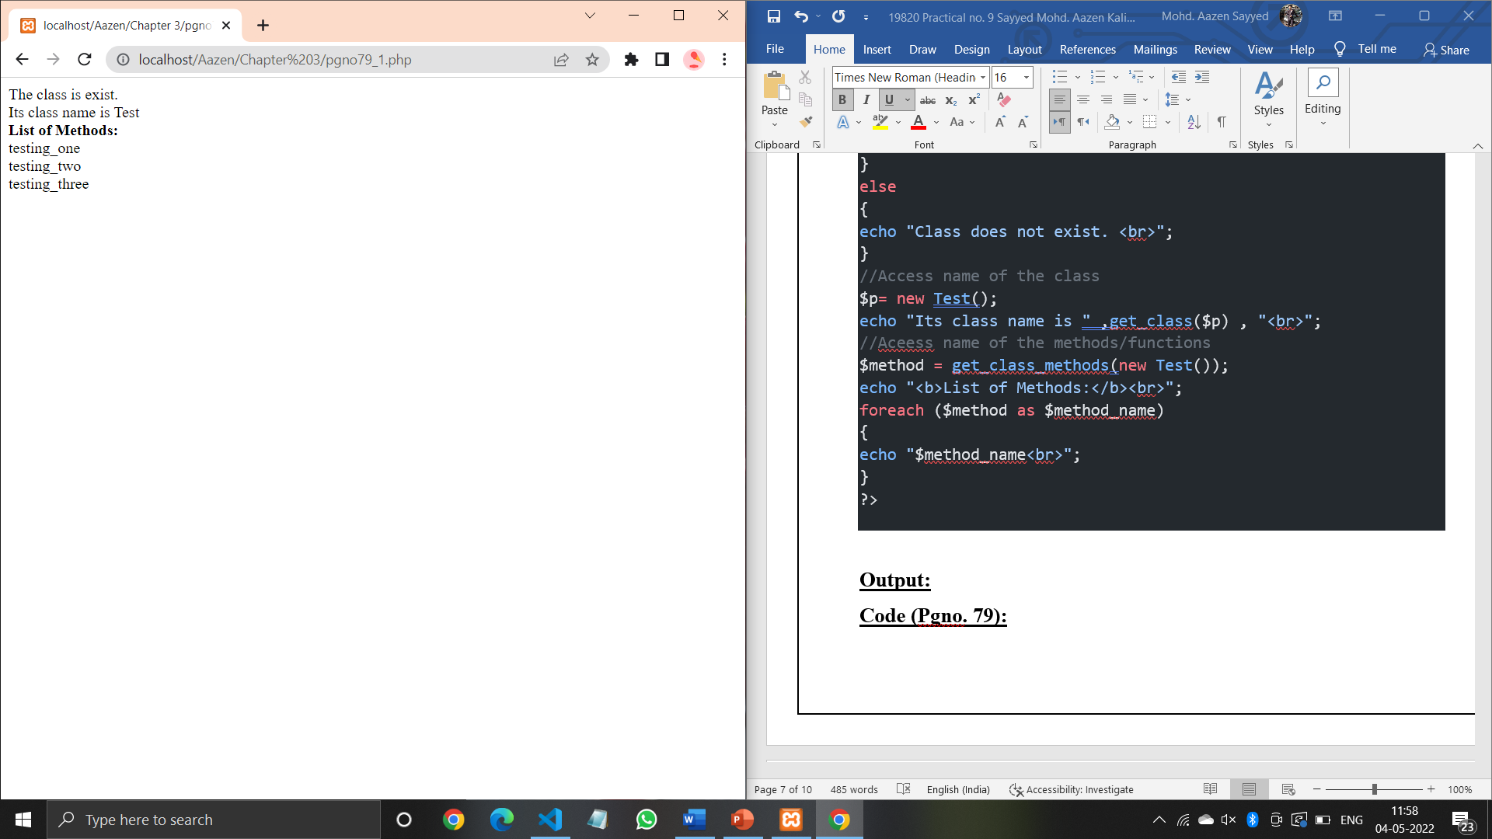

**Code (Pgno. 79):**

<?php

interface MyInterfaceName

{

 public function method1();

 public function method2();

 }

 class MyClassName implements MyInterfaceName

{

 public function method1()

 {

 echo "Method1 Called" . "<BR>";

 }

 public function method2()

 {

 echo "Method2 Called". "<BR>";

 }

}

if (interface_exists('MyInterfaceName'))

 {

 echo "Interface exists.<br>";

 }

 else

 {

 echo "Interface does not exists.<br>";

 }

$obj = new MyClassName;

$obj->method1();

$obj->method2();

?>

**Output:**

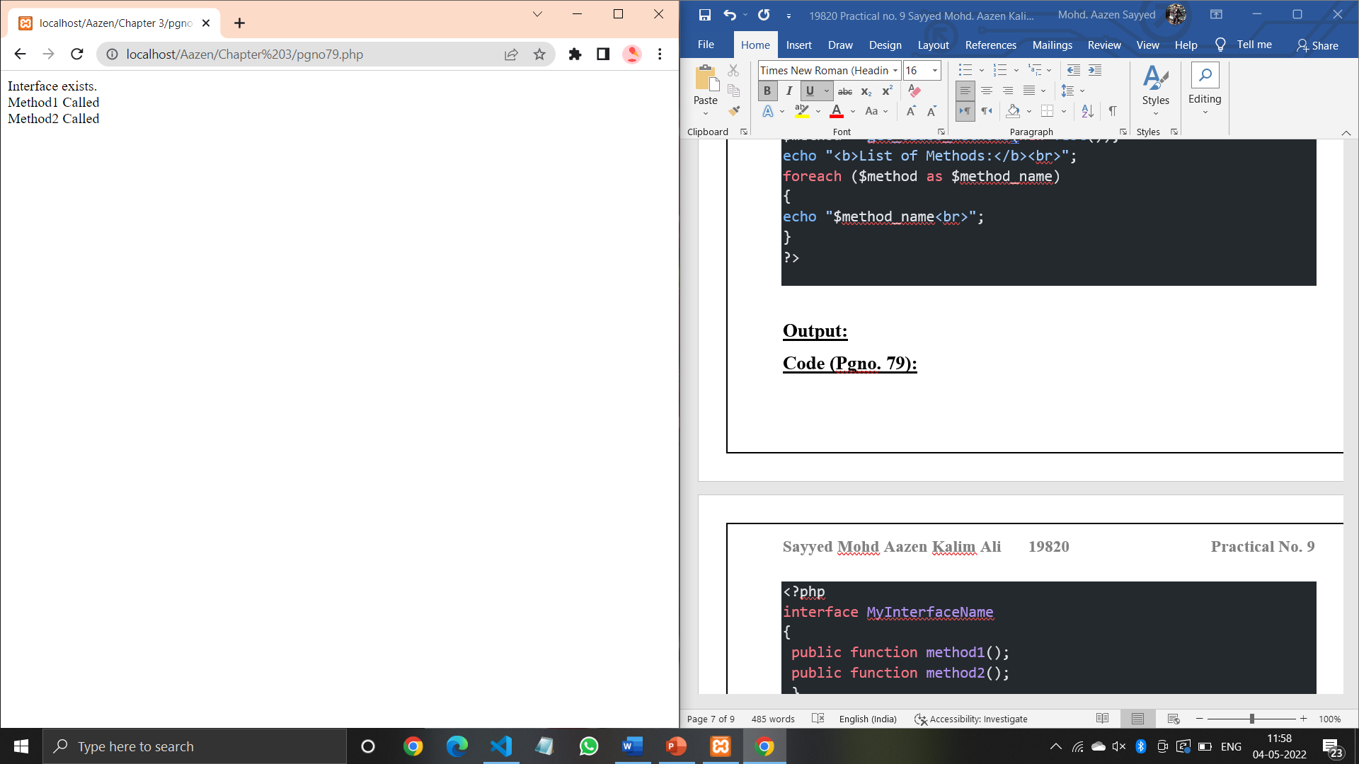

**Code (Pgno. 80):**

<?php

$s_data=serialize(array("Welcome","to","PHP"));

print_r($s_data."<br>");

$us_data=unserialize($s_data);

print_r($us_data);

?>

**Output:**

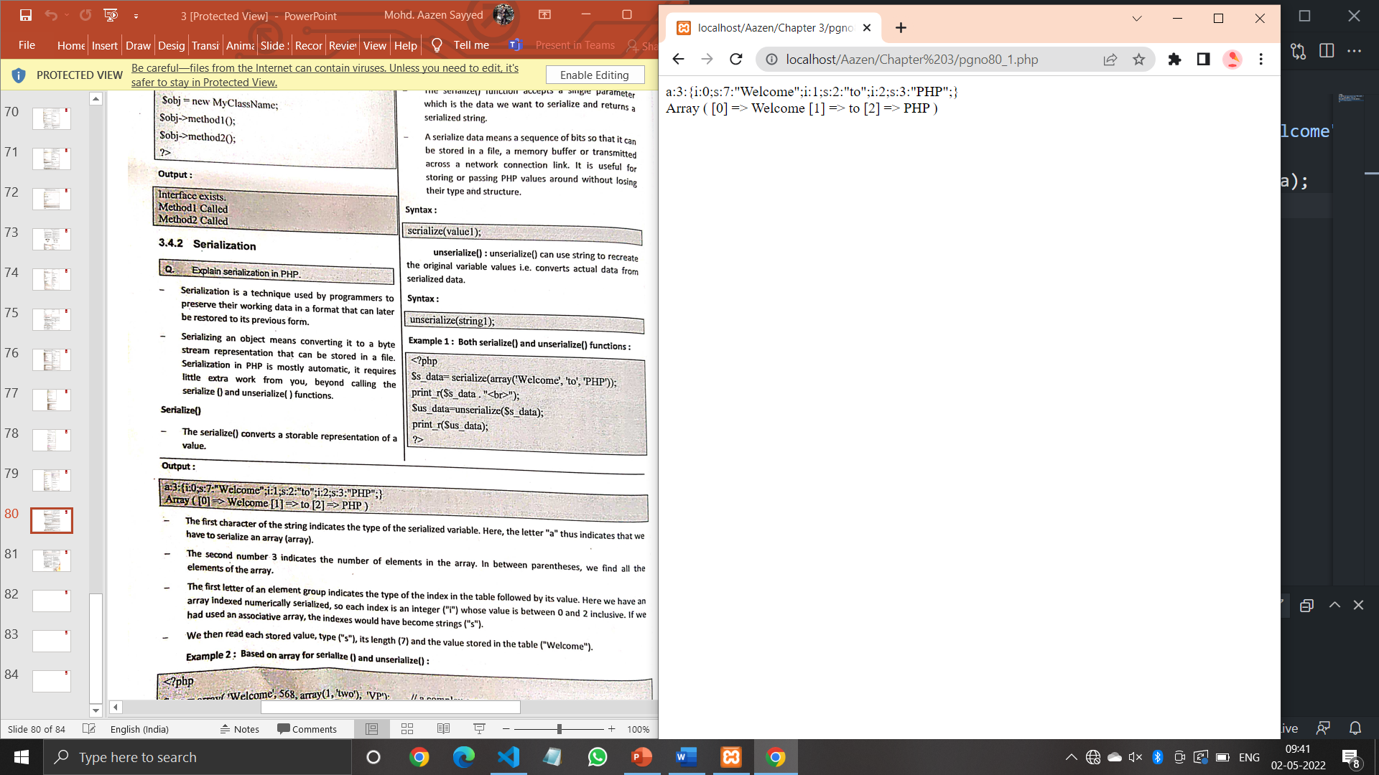

**Code (Pgno. 80):**

<?php

$var=array("Welcome",568,array(1,'two'),"VP");

$string=serialize($var);

print_r($string."<br>");

$newvar=unserialize($string);

print_r($newvar);

?>

**Output:**

